|  |  |
| --- | --- |
| **Practicum Case** |  |
| CPEN6247 | CPEN6247001  Computer Networks |
| **Computer Engineering** | **O221-CPEN6247-PH01-04** |
| ***Valid on*** *Odd Semester Year 2021/2022* | **Revision 00** |

## Learning Outcomes

* LO1 – basic concepts of network
* LO2 – concepts of create network environment

## Topic

* Session 4 – Routing Techniques – Static Routing

## Sub Topics

* Routing Concepts
* Static Routing Basic
* Static Routing Advanced

## Soal

*Case*

1. **Routing**

Routing is the process of selecting a path to deliver a packet from the source to the destination. The router will forward the packet based on the information inside the packet header. To determine the correct route for the packet, a router will have a routing table. This routing table will save all paths that each packet should take to reach every destination that the router is connected to.

The routing table can be either static or dynamic. In a static routing table, the routine doesn't change itself. It needed to be manually set up by the network administrator. Meanwhile, a dynamic routing table updates automatically. Dynamic routing also requires more computing power, which is why smaller networks tend to use static routing rather than dynamic routing to save resources. Meanwhile larger networks tend to use dynamic routing because it is a lot more efficient.

1. **Static Routing**

For example, we have the following network topology:

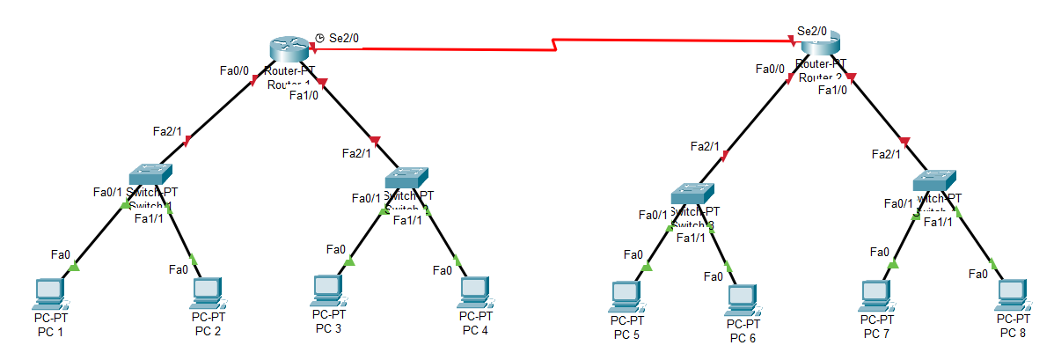

Below are the IP address that will be used:

**PC:**

* **PC 1** = 192.168.0.2/24
* **PC 2** = 192.168.0.3/24
* **PC 3** = 192.168.1.2/24
* **PC 4** = 182.168.1.3/24
* **PC 5** = 192.168.2.2/24
* **PC 6** = 192.168.2.3/24
* **PC 7** = 192.168.3.2/24
* **PC 8** = 192.168.3.3/24

**Router:**

* **Router 1**
  + **Fa0/0** = 192.168.0.1/24
  + **Fa1/0** = 192.168.1.1/24
  + **Se2/0** = 192.168.4.1/24
* **Router 2**
  + **Fa0/0** = 192.168.2.1/24
  + **Fa1/0** = 192.168.3.1/24
  + **Se2/0** = 192.168.4.2/24

After we already set all of the device's IPs, the devices under the same router can now communicate with each other. For example, PC 1 with PC 2 and PC 1 with PC 3 can communicate with each other. But, the devices under the different routers cannot communicate with each other, for example, PC 1 with PC 5. This is because Router 1 still doesn't know the position of PC 5. After all, it is not directly connected to the router. We can check this by going to the CLI tab on Router 1 and typing in the **show IP route**. Show IP route is used to see the routing table inside that router.

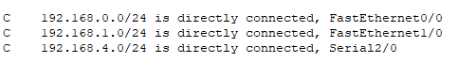

We can see from the screenshot above that Router 1 is only directly connected to 192.168.0.0 and 192.168.1.0 which is the network address of PC 1, PC 2, PC 3, and PC 4. Therefore, we can use static routing to connect the router with the remaining devices.

To do static routing, we can use the command IP route. The syntax of the IP route is:

***ip route [Network Address] [Subnet Mask] [Route Taken]***

Where network address is the network address of the network that we want to connect, a subnet mask is the subnet mask of the network that we want to connect, and the route taken is the route that is needed to be taken to the network.

So, to connect our current network topology, we need to input the following command:

* **Router 1**
  + ip route 192.168.2.0 255.255.255.0 192.168.4.2
  + ip route 192.168.3.0 255.255.255.0 192.168.4.2
* **Router 2**
  + ip route 192.168.0.0 255.255.255.0 192.168.4.1
  + ip route 192.168.1.0 255.255.255.0 192.168.4.1

Now, if we try to send a packet from PC 1 to PC 5, the packet should be successfully sent because we already connected the two network using static routing.

1. **Case**

Quantum & Clock has become bigger and currently building a two-floor office. Each floor will have a router for rooms inside that floor. Quantum & Clock wanted all devices inside the network to be able to communicate with each other. Therefore, you as a network engineer is asked to make static routing for the network based on the network below.

